Cross Sections for electron-impact on CO₂

Concept
Electron impact cross sections on water and CO2 have some substantial differences, particularly in the vibrational and elastic modes.
How much would these differences impact the cooling and ionization rates in the coma, given the same set of fields? What asymmetry could be achieved purely through the differences in collisionality between species?
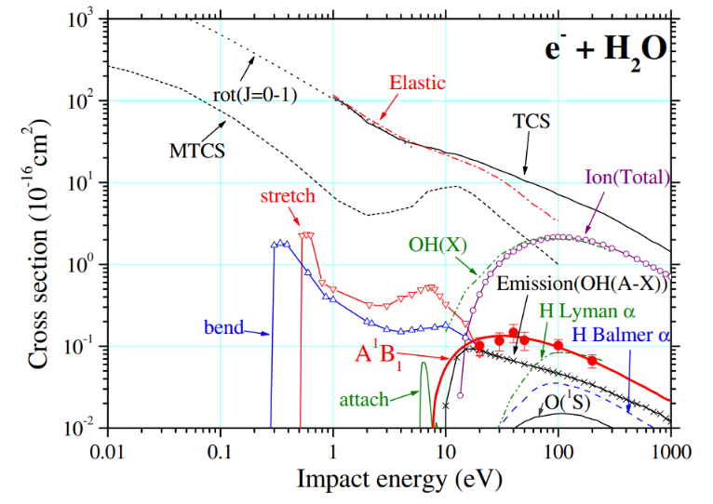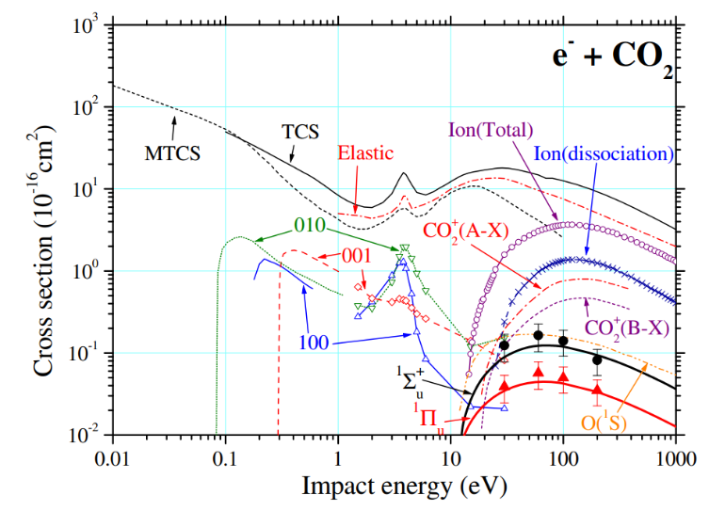

Key References
- (Itikawa, 2002)
- (Kawahara et al., 2008) – Electronic excitation of 1Simga+u and 1PiU of CO2
- (McConkey et al., 2008)
- (Anzai et al., 2012)

Vibrational Modes
- High energies, use data from Kitajima.
- At low energies, can use Nakamura and Kochem data.
- (100) mode – Kochem is more reliable
- (001) and (010) – Nakamura is best at low energy
